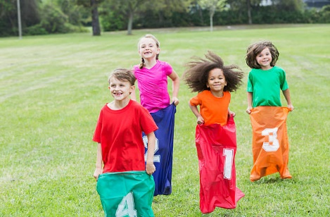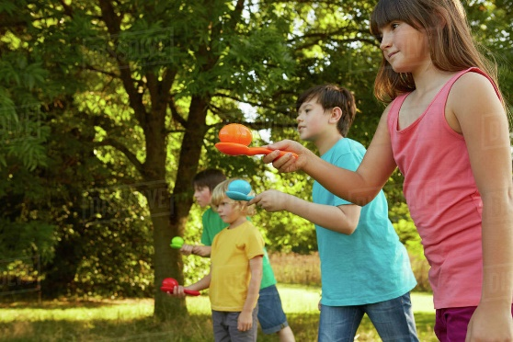

**Key vocabulary**

**Balance** – staying upright and steady (not falling over).

**Speed** – the rate at which something moves.

**Warm Up** – to prepare for physical activity by exercising or practising gently beforehand.

**Distance** – the length of space between two points (how far apart two things are is the distance between them).

**Throw** - to make something move forward with force through the air by a movement of the arm and hand.

Athletics – Year 1

Sports Day

