Year 4 DT Spring 1
Building a structure to withstand an earthquake and volcanic eruption.

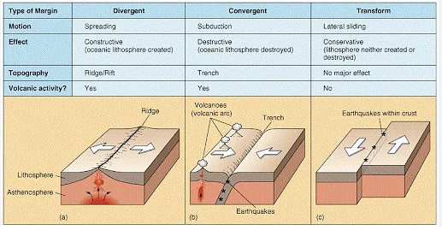
Types of Tectonic Plates
Key Knowledge

Structures need to be stable and solid.
Choose appropriate material and explore different ways of combining them.
Draw a labelled diagram of their design including measurements.
Decide how to make a structure sturdy by testing different ways.
Key Vocabulary
Purpose
Model
Stability
Structure
Tectonic Plate
Shock Absorber
Cross Brace
Richter Scale
Pyroclastic Flow

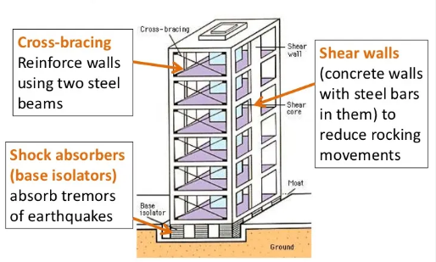
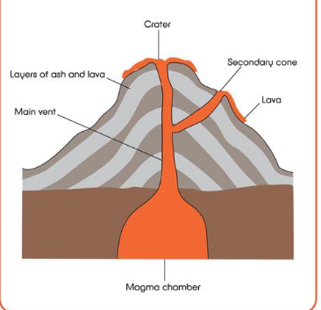
The cross section of a volcano
The objective is to research, design and make a structure that can withstand an earthquake and a volcanic eruption. Points to consider.
- What will I need to think about?
- How big or small will it be?
- Which architectural influences will I use?
- Which materials will I use?

