Term: Autumn 1 Topic: Once upon a time Year Group: Reception
 | English | Maths | Wider Curriculum
 | The gingerbread man, Owl babies | Getting to know me, Just Link me! | All About me
Book links | 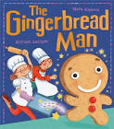 | 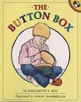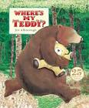 | 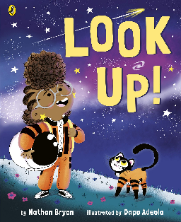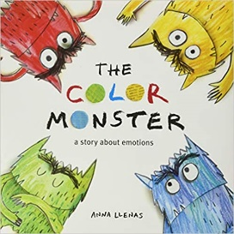
Specific Vocabulary | Letter  Letter name  Letter sound  Special friends (phonics)  Blend  segment | Sort  Same  Different  small and large  tall, long, short | Family  Share  Happy  Sad  Angry  Emotions
sticky Knowledge about… | Letters have a name and they make a sound.  I know set one sounds:  M, a, s, d, t, i, p, n  Letters are used to make words.  When there is a gap between letters that is the start of a new word.  Books need to be looked after  A traditional tale is a folk tale or fairy story which has been passed down for many generations.  A traditional tale starts with one upon a time. | When something is the same it matches.  Objects can be sorted into sets based on attributes such as size, shape or colour.  The same collection of objects can be sorted in different ways.  When comparing set they can have more, fewer or the same number of items in them.  Objects can be compared according to their size, weight or capacity.  A pattern is a repeated arrangement of things. | We are all part of a family  All families are special yet they all look different and have different people in them.  These differences don’t matter. What is important is that you’re your family you all love and respect each other.  We have lots of different emotions including happy, sad, angry, fear, calm and love.  It is ok to be sad sometimes.  There are lots of things we can to help ourselves when we feel angry.

