Year 6 History Knowledge Organiser
Term: Autumn 1 | Topic: Wars over time | Strand: Theme in British History beyond 1066
1066 | 1096 and 1291 | 1337 - 1453 | 1455 - 1485 | 1642 - 1651 | 1914 – 1918 | 1939 - 1945
Battle of Hastings | The Crusades – religious war | Hundred Years’ War (conflict between kings from the middle ages) | War of the Roses (families at war Yorks vs Lancasters) | English Civil War (country at war with self) | First World War (countries with war with each other) | Second World War
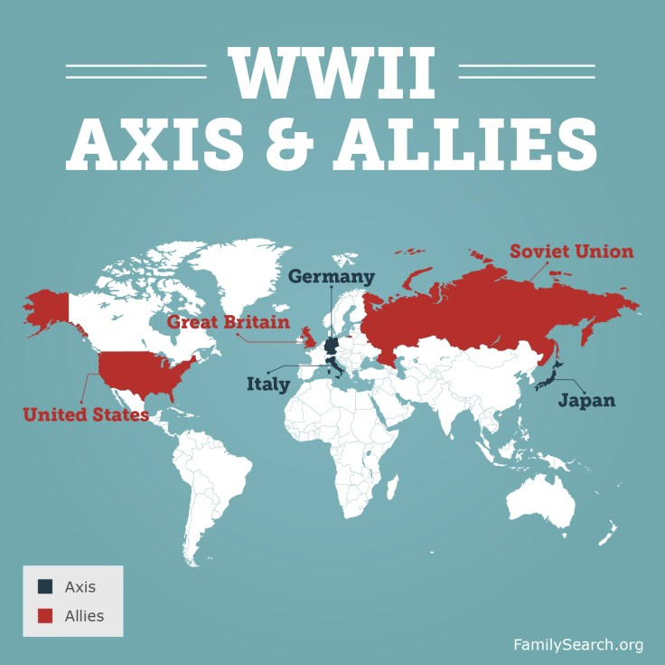
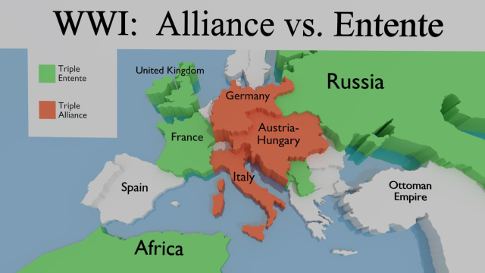
Key Vocabulary
battle | A sustained fight between two large organised armed forces to achieve or resist something.
war | Armed conflict between different countries.
civil war | A war between citizens of the same country.
propaganda | Controlling media (radio) or images to show your side in the best way.
ally | A country that supports and helps another country in war.
Blitz | A series of aerial bombing raids on the UK.
rationing | Controlling the supply of food clothes and resources.
Treaty of Versailles | A written agreement signed at the end of WW1 which named Germany as the cause of the war.
appeasement | The act of trying to please or compromise with someone.
Five key facts that I will recall by the end of this unit
-Oliver Cromwell was part of the Civil War as he did not believe in the religious ideas of the King – Charles 1.
-WW1 began and ended on 28th July 1914 – 11 November 1918.
-WW1 happened because of the assassination of Archduke Franz Ferdinand of Austria by Gavrilo Princip from Bosnia.
-WWII began on 1st September 1939 and ended 2nd September 1945.
-WW2 began when Germany invaded Poland.
-Some countries, like Spain and Switzerland, were neutral meaning that they did not get involved in WW2.
WW1 – key people
Gavrilo Princip
Franz Ferdinand

WW2 – key people
Adolf Hitler
Winston Churchill
Neville Chamberlain

