Hello and Welcome to Year 1!

We hope that you have had a lovely time over the summer holidays and are ready to work hard in Year 1.

We are so excited to start our learning this term, and are sure that you will all enjoy it too!

PE will be on a Tuesday and Thursday afternoon so you will need to make sure to have your PE kit in school on these days. Your PE kit can stay in school to make sure we have it ready for these days.

Remember to bring a water bottle into school with you, not forgetting to take it back home with you.

In Year 1, you will be given homework which will be sent home on Fridays. Each week we will send home a Learning Log task and a piece of Numeracy. You need to bring your homework back in on the following Wednesday. Spellings will also be sent home every Friday and will be in a separate spelling book.

We will change your reading book and will read together during ‘Guided Reading’.

Always remember to bring your reading book into school with you, along with your reading log.

Try to practise at home with your grown-ups, this way you will become superstar readers! It would be lovely to hear about books you have enjoyed reading ☺

We can’t wait to see all of your wonderful work this term!

Miss Curry and Mrs Adshead

Enrichment

This term we will be visited by the Fire Brigade and the children will have the opportunity to board an engine and try out the hoses. We are also planning a mock baptism with Rev Ackroyd.

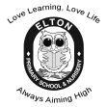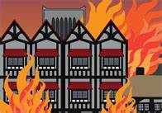

**Year 1 Learning Leaflet**

**AUTUMN 2018**

**Fire! Fire!**

Fire! Fire! Is a topic based on the historical event of the Great Fire of London. The children will learn about what happened and why and consider fire safety in the home.

In **Geography** we will be learning about the four countries of the UK: England, N. Ireland, Scotland and Wales. We will locate them on a map and identify the characteristics of each county and the surrounding seas. In the second half term we will focus on London as we explore the historical event of ‘The Great Fire of London’

In History we will learn about the significant historical events: The Great Fire of London, Bonfire Night and Remembrance Day. We will be learning about significant historical people such as Samuel Pepys and Guy Fawkes.

In P.E (Games) we will learn how to travel and how to send and receive a ball effectively. In Gymnastics we will be developing balance, agility and coordination.

In Music we will learn ‘London’s Burning’ and a range of traditional songs from the UK. We will explore different instruments.

In computing we will be using the app ‘Pic Collage’ to create a collage relating to our topic. We are learning about how to use technology safely. Children will learn how to send emails, visit safe sites and search for information.

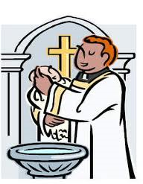

In English we will be writing labels, lists and captions linked to Information texts about the UK. We will read, write and follow simple recipes for traditional UK food. Then we are studying ‘Goldilocks and Just the One Bear’ In this award-winning author and illustrator’s witty sequel to the traditional Goldilocks story where Little Bear is all grown up and Goldilocks is a distant memory. The children will be writing their own stories set in familiar settings, persuasive letters and information texts. Linked to our topic on the UK, we will read The Queen’s Knickers and The Kiss that Missed. We will be writing Bonfire poems and towards Christmas we will be studying the text ‘Lost and Found’ by Oliver Jeffers.

In R.E we will be learning about the Christian story of Creation. Children will learn about the Christian sacrament of baptism and the Story of Christmas. We will discuss what makes a good friend and share stories from the Bible.

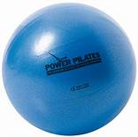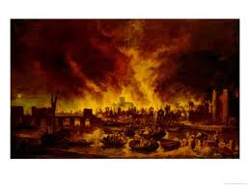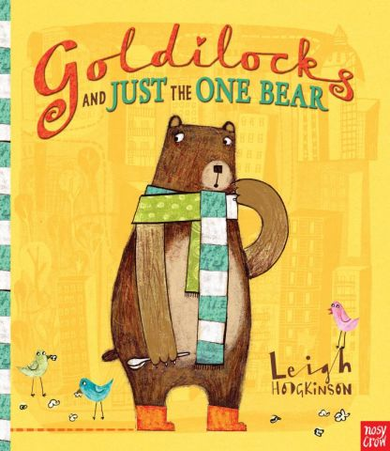

In **Art** we will learn how to do simple colour mixing. We will use these skills to paint a picture of The Great fire of London.

In DT we will be making a range of traditional foods from the 4 countries in the UK.

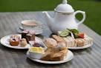

In Maths we will be reading and writing numbers to 10 and identifying one more and one less. We will be counting forwards and backwards from any number. We will be using number bonds to solve one step addition and subtraction problems. We will learn to read, write and interpret mathematical statements involving + - and = signs. We will learn to count in 2s, 5s and 10s. We will recognise and name common 2D and 3D shapes.

In Science we will have a weekly focus on seasonal change- tracking weather and the changes in plants. Our main topic is Materials. We will name and identify the properties of different common materials and conduct an experiment to consider the suitability of materials.

