Welcome back!

We hope that you have had a lovely time over the Christmas break.

We are looking forward to an exciting term ahead.

PE will be on a Tuesday and Friday afternoon so you will need to make sure to have your PE kit in school on these days. Your PE kit can stay in school to make sure we have it ready for these days.

Remember to bring a water bottle into school with you, not forgetting to take it back home with you.

Homework will be sent home on Fridays. Each week we will send home a Learning Log task and a Numeracy homework. You need to bring your homework back in by the following Wednesday.

We will change your reading book and will read together during ‘Guided Reading’.

Keep up the excellent reading at home, every day if you can! Parents could you please write a comment in the yellow reading diary e.g. did the children enjoy the story? Could they retell and answer questions about the book?

**Please keep their reading book and reading diary in their book bag and send it in every day**. We will read with your children more than once a week.

We can’t wait to see all of your wonderful work this term!

Miss Curry and Miss Adshead

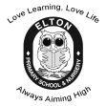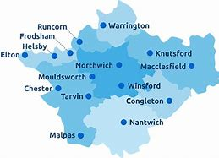

**Year 1 Learning Leaflet**

**Spring 2019**

In **Geography** we will be learning about our local area. We will locate our village on a map and identify the characteristics of the surrounding areas. We will learn to recognise the human and physical features of Elton. We will use simple fieldwork and observational skills to study the surrounding areas. We will develop our knowledge about the locality including houses and jobs.

**Where We Live**

Where We Live is a topic based on the human and physical features of Elton school and Village. The children will use field work, observational skills and map work to learn about the local area.

In Computing we will be learning how to log on to the computers and use word processing documents as well as creating art. We will also collect data and present it in different ways e.g. bar graphs and pictograms.

In P.E we will continue to learn how to travel and how to send and receive a ball effectively. In Gymnastics and dance we will be developing balance, agility and coordination.

In Music we will listen to and learn songs, as well as exploring different sounds and instruments. We will focus on rhythm.

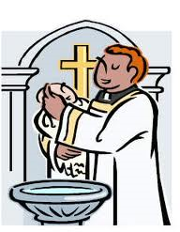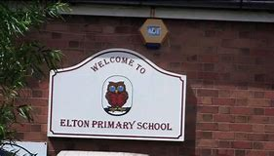

In English we will be writing for lots of different purposes – instructions, posters, stories etc. We will be studying ‘The Bog Baby’. The Bog Baby is a truly magical story by Jeanne Willis and Gwen Millward. We will be talking in depth about the story, sequencing it and acting it out. We will write detailed descriptions and complete an extended write. We will go on a Bog Baby hunt and learn all about different habitats. We will also be looking at another story from the same author.

In R.E we will be learning about the Kingdom of God. We will look at different stories from a variety of religions and discuss friendship and what makes a kind friend. We will look at morals behind these stories and think about consequences of different actions.

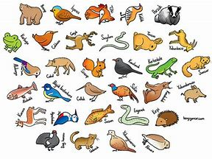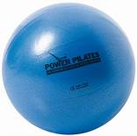

In Maths we will be focusing on Addition and Subtraction and Place value within 50. We will be using tens frames, dienes and numicon in our Maths lessons to support us. We will be counting on and making number bonds. We will be comparing number sentences and subtracting crossing 10. We will be counting in 2s, 5s, and 10s. We will be using our maths skills to solve mathematical reasoning problems.

In Science we will be looking at animals. We will identify and name a variety of common animals including fish, amphibians, reptiles, birds and mammals. We will identify carnivores, herbivores and omnivores and describe and compare the structure of a variety of common animals. We will also identify, name, draw and label the basic parts of the human body and say which part of the body is associated with each sense.

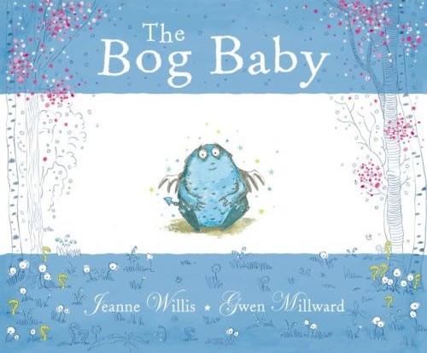

In **Art** we will be looking at the work of LS Lowry and using his art to inspire us to sketch our locality.

