Key vocabulary | Definition
volcano | An opening in the Earth's crust from which lava, ash, and hot gases flow or are ejected during an eruption. Usually a cone shaped mountain.
magma | Hot fluid or semi-fluid material below or within the earth's crust from which lava and other igneous rock is formed on cooling
Mount Vesuvius | An active volcano in Southern Italy.
lava | Lava is a liquid, that cools into rock, which is a solid.
Pompeii | A Roman city in Southern Italy near the coast of Bay of Naples which was buried under metres of ash and pumice after Mount Vesuvius erupted in 79 A.D.
Earth’s crust | A thin shell on the outside of the Earth.
eruption | When magma is released from a volcano
earthquake | A sudden violent shaking of the ground, typically causing great destruction, as a result of movements within the earth's crust or volcanic action.
tectonic plates | Earth's outer layer is made up of large, moving pieces called plates. All of Earth's land and water sit on these plates. The plates are made of solid rock.

Pompeii
Pompeii is a city in Southern Italy near the coast of Bay of Naples which was buried under metres of ash and pumice after Mount Vesuvius erupted in 79 A.D.
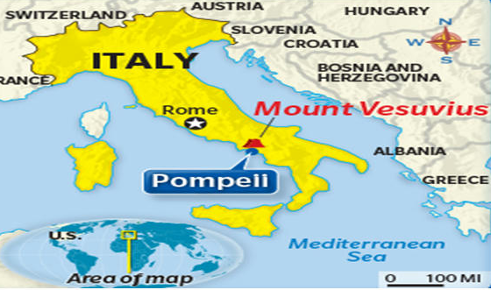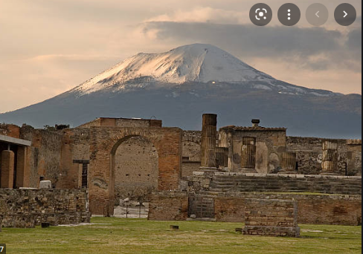
Focus on Roman Empire and City of Pompeii
Key Knowledge
How are volcanoes formed? | 1. Magma rises through cracks or weaknesses in the Earth's crust.  2. Pressure builds up inside the Earth.  3. When this pressure is released, e.g. as a result of plate movement, magma explodes to the surface causing a volcanic eruption.  4. The lava from the eruption cools to form new crust.  5. Over time, after several eruptions, the rock builds up and a volcano forms. | 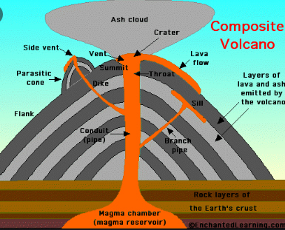
What causes an earthquake? | An earthquake is the shaking and vibration of the Earth's crust due to movement of the Earth's plates (plate tectonics). Earthquakes can happen along any type of plate boundary. Earthquakes occur when tension is released from inside the crust. Plates do not always move smoothly alongside each other and sometimes get stuck. When this happens pressure builds up. When this pressure is eventually released, an earthquake tends to occur. | 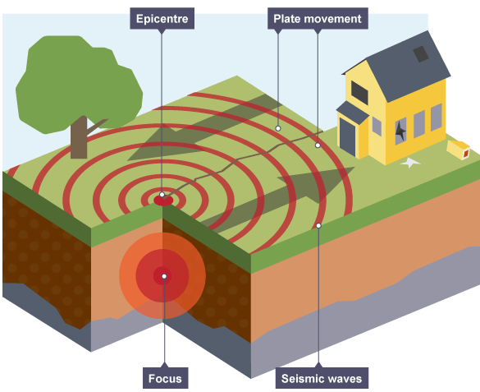
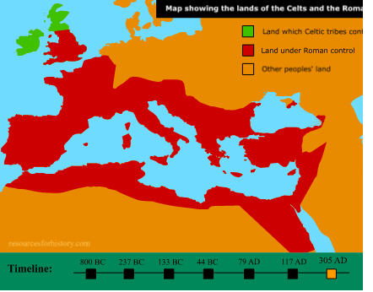
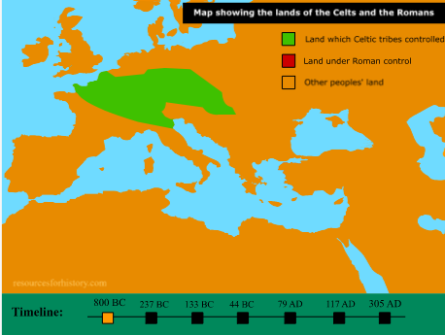
305 A.D.
800 B.C.
The spread of the Roman Empire
Volcanoes and Earthquakes Knowledge Organiser – Spring 1 – Year 4

