Key vocabulary
plan | develop
design | material
evaluate | waterproof
equipment
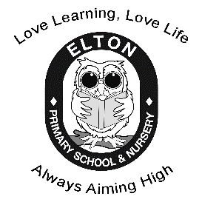
Will our boat float?
How can we make our rockets move?
DT – Year 1
Boats and rockets

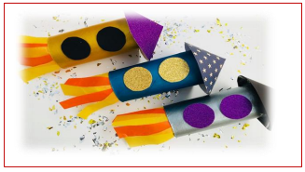
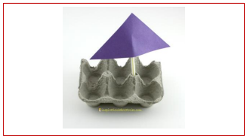
develop | grow or cause to grow and become more advanced, or improved
waterproof | something that keeps water out.  Water cannot pass through an object or material that is waterproof
equipment | the right items for a task
material | the matter from which a thing is or can be made
evaluate | to assess and judge the item you have made
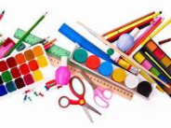
We need to think about which material would be best:
cling film
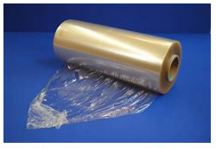
cork
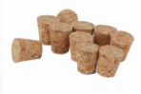
cardboard
