Welcome to the Reception dream team! We hope you have had a fantastic summer and we are looking forward to an exciting term ahead with you. Your teaching team this year consists of Mrs McCarroll and Mrs Hodgson.

Uniform: We expect all children to wear school uniform. Please ensure all items of uniform are labelled including coats, shoes and PE Pumps, book bags etc.
PE: - Drawstring pump bag/labelled, pull on/Velcro black pumps, navy or black shorts, white T-shirt.PE will be on Tuesday and Thursday. P.E. kit can be taken home to be washed half termly. Please bring in a water bottle that your child can identify which can be filled with fresh water every day.
When we feel your child is ready we will start sending reading books home. Please read with your child as often as possible, every day if you can. Please write a comment in the yellow diary eg. Did they enjoy it? How well are they blending? Could they retell the story? Could they discuss the character’s behaviour? The more practice your child gets, the quicker your child will become fluent. We will change your child’s reading book once a week and we will read with them at least once a week. Please keep the reading book and yellow reading diary in their book bag and send it in every day.
Late arrivals: Children who arrive after 8:45am are considered late for school. All late arrivals should use the main entrance and will be requested to sign the late book.
Absence: Parents are asked to phone the school office if their child is absent and the reason for the absence. If parents do not let the school know the reason for the absence on the first day then the secretary will phone to ensure there are no problems.
Medicines: Requests for medicine to be administered in school must be made to the school office. This relates ONLY to prescribed medicines. They should be handed in to the school office with clear written instructions on their administration to the child. Antibiotics will be stored in the fridge until the end of the day. The fact that the medicine has been administered will be recorded in the medicine log book. Asthma Inhalers are kept in the classroom where the children can obtain them easily.

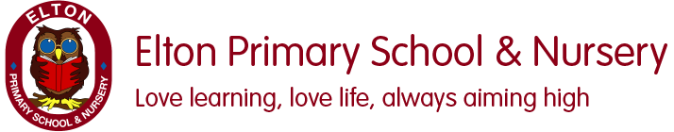.

Over the first few weeks of term we will be getting to know each other, making new friends as well as finding out about the things we like to do and enjoy our new school!

Term: Autumn 1 Topic: Once upon a time Year Group: Reception
 | English | Maths | Wider Curriculum
 |  | Getting to know me, Just Link me!
Book links | 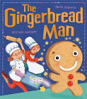 | 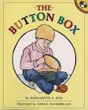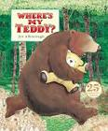 | 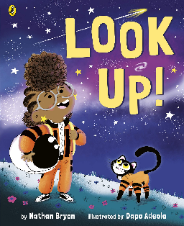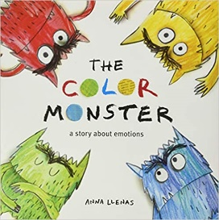
Specific Vocabulary | Letter  Letter name  Letter sound  Special friends (phonics)  Blend  segment | Sort  Same  Different  small and large  tall, long, short | Family  Share  Happy  Sad  Angry  Emotions
sticky Knowledge about… | Letters have a name and they make a sound.  I know set one sounds:  M, a, s, d, t, i, p, n  Letters are used to make words.  When there is a gap between letters that is the start of a new word.  Books need to be looked after  A traditional tale is a folk tale or fairy story which has been passed down for many generations.  A traditional tale starts with one upon a time. | When something is the same it matches.  Objects can be sorted into sets based on attributes such as size, shape or colour.  The same collection of objects can be sorted in different ways.  When comparing set they can have more, fewer or the same number of items in them.  Objects can be compared according to their size, weight or capacity.  A pattern is a repeated arrangement of things. | We are all part of a family  All families are special yet they all look different and have different people in them.  These differences don’t matter. What is important is that you’re your family you all love and respect each other.  We have lots of different emotions including happy, sad, angry, fear, calm and love.  It is ok to be sad sometimes.  There are lots of things we can to help ourselves when we feel angry.

