Ready Steady…

[](https://www.google.co.uk/url?sa=i&url=http%3A%2F%2Fclipart-library.com%2Fbake-sale-clipart.html&psig=AOvVaw3_a4K0dZNRHkg8fgPgfdFO&ust=1611841081631000&source=images&cd=vfe&ved=0CAIQjRxqFwoTCNj5zpievO4CFQAAAAAdAAAAABAE)

… together!

You are invited to join us online for a 1-hour workshop that will give you and your child an opportunity to bake together at home.

[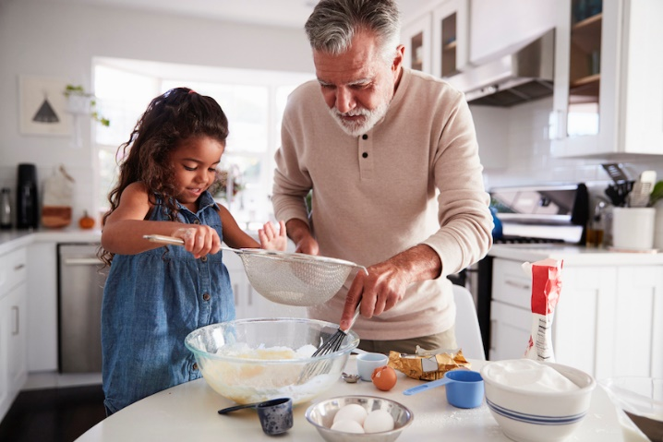](https://www.google.co.uk/url?sa=i&url=https%3A%2F%2Fwww.bettertogetherbc.ca%2Fblog%2Fsingle%2Fhow-to-cook-with-your-kids&psig=AOvVaw0-IHBNSvJp3te-U9J2Mg6w&ust=1611840965388000&source=images&cd=vfe&ved=0CAIQjRxqFwoTCICqtN6dvO4CFQAAAAAdAAAAABAD)

Friday 26th Feb

1-2pm

OR

Friday 5th March

10am-11am

Interested? Please let your child’s school know by Tuesday 9th February giving your name, email address, telephone number and preferred date.

The programme will run on Microsoft Teams and once you have signed up, your Tutor will be in touch to discuss details.

**Please note:**

So that we can offer this course free of charge, you will be required to complete some paperwork.

You will also need to have access to materials from a list that will be emailed to you.

Please ensure that your video camera works on the device that you are going to use.

**Future Family Learning programmes April onwards:**

Help Your Child with English, Family Maths, Family Health and Wellbeing and many more…