Spreadsheet | A computer application used to store and organise data
Formula | A mathematical rule expressed in symbols
Branding | A mark/symbol to represent something
Graphics | An art that enhances visual communication/advertisement online
Variables | Something that can change or vary in value
Search engine | a machine with moving parts that converts something into information
Digital tools | Digital tools are programs, websites or online resources that can make tasks easier to complete.
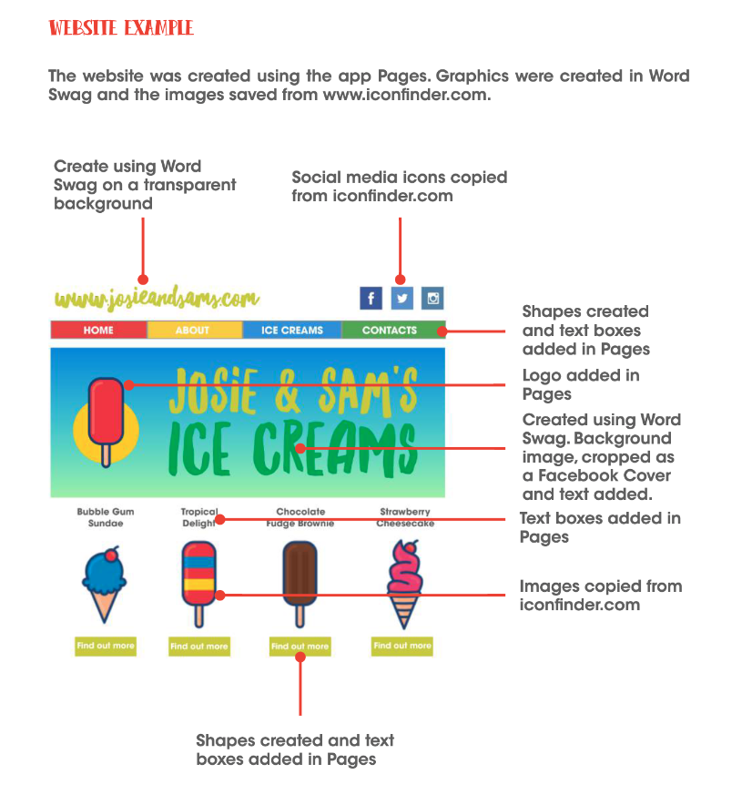
Year 6 – computing knowledge organiser – Spreadsheets and website design

Unplugged
Solving

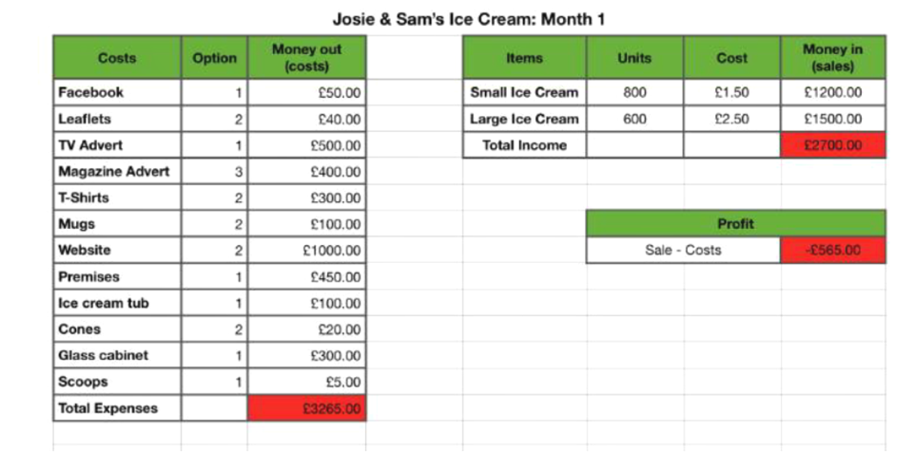
Formulas
Formulas help to identify values from different cells to help you complete quicker/more efficient calculations and procedures.

E.g. =SUM
This helps to add two values from different cells.

Computing skills
Information Technology
Design a suitable brand for a business and promote it.
Create a spreadsheet with formulas for profit and loss of a business.
Work independently to create a presentation that includes graphics, images and movies.
Design and build a webpage and share it online.
Make a presentation to an audience using digital tools.
Computer Science
Create variables in spreadsheets and understand their role in a program.
Digital Literacy
Access and justify when it is acceptable to use the work of others.
Explain how search engines work and how results are selected and ranked.

