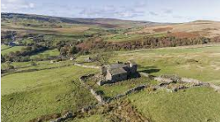
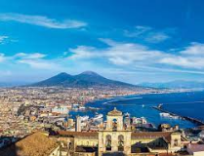
Year 4 –Geography - Focusing on similarities between North West and Bay of Naples
Vocabulary | Definition
contour lines | The contour lines join up areas of the same height, and when they are close together it means the hill or mountain is steep.
Ordnance survey map | maps that show the physical and human features of the UK
scale | show the reader what the distance you measure on your map, means in real life
symbol | small pictures that stand for different features on a map
4 figure grid reference | used on a map to pinpoint a location to within a square
physical features | They would be here even if there were no people around. Physical features like seas, mountains and rivers are natural.
human features | They have been built by people like houses, roads and bridges.
Ordnance survey map | maps that show the physical and human features of the UK
scale | show the reader what the distance you measure on your map, means in real life
symbol | small pictures that stand for different features on a map

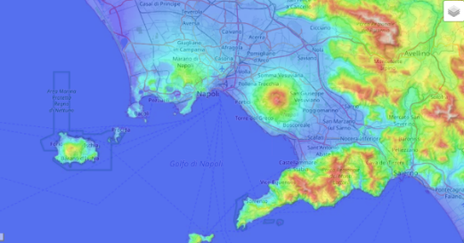
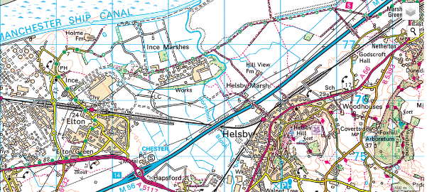
Bay of Naples
North West of England
North West of England
The North west is a wide area and contains a variety of land use (e.g. built up residential and business areas as well as farmland, woodland and coastal areas different sized settlements from villages to cities such as Manchester and Liverpool. There are areas, which are flat, but also hilly, mountainous areas, such as the Pennines and Lake District.

Bay of Naples – South-Western coast of Italy
The Naples Bay region is dominated by the coast and Mount Vesuvius (volcano) and the human features are influenced by these.
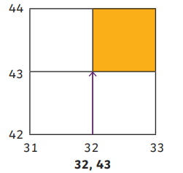
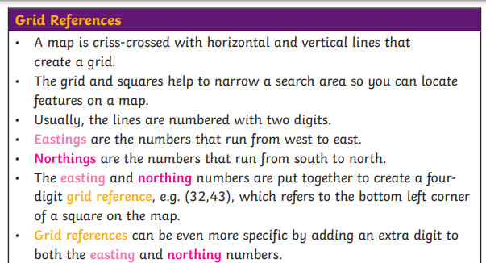

Similarities and differences of Bay of Naples and North West of England
There are no active Volcanoes in the UK region and we experience only slight earthquake tremors in the UK. There are many similarities – a large urban area with lots of tourism attractions, close to coastline, rich farmland in the rural areas, problems of traffic congestion.

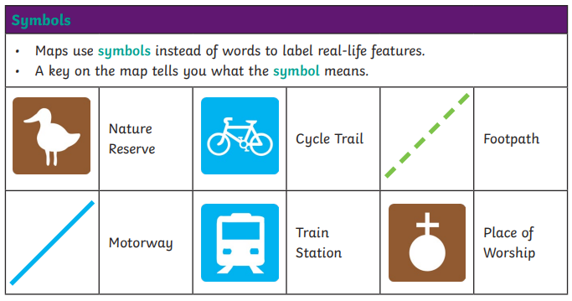
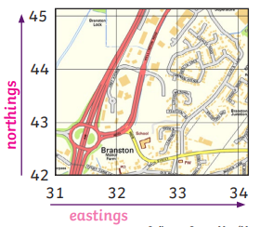
Four-figure grid references
Four-figure grid references
Human and physical features are things that you can see all around you.
Physical features like seas, mountains and rivers are natural. They would be here even if there were no people around.
Human features like houses, roads and bridges are things that have been built by people.

