Key Vocabulary
electricity | A form of energy used for lighting, heating, making sound and making machines work.
electrical appliance | A machine or device that runs on electricity.
mains | The electricity supplied to households from power stations.
electrical circuit | This consists of a cell or battery connected to a component using wires. It needs to be a complete circuit to work.
cell and battery | A cell is a single unit and a battery is a collection of cells.
electrical component | A part that combines with others to form a circuit. E.g. bulb, motor, buzzer
switch | Can be added to a circuit to turn a component on or off. It allows the electricity to flow or it stops it.
conductor | Material that allows electricity to pass through.
insulator | Material that does not allow electricity to pass through it.

Appliances that run on electricity
Some plug into the mains and others run on batteries.
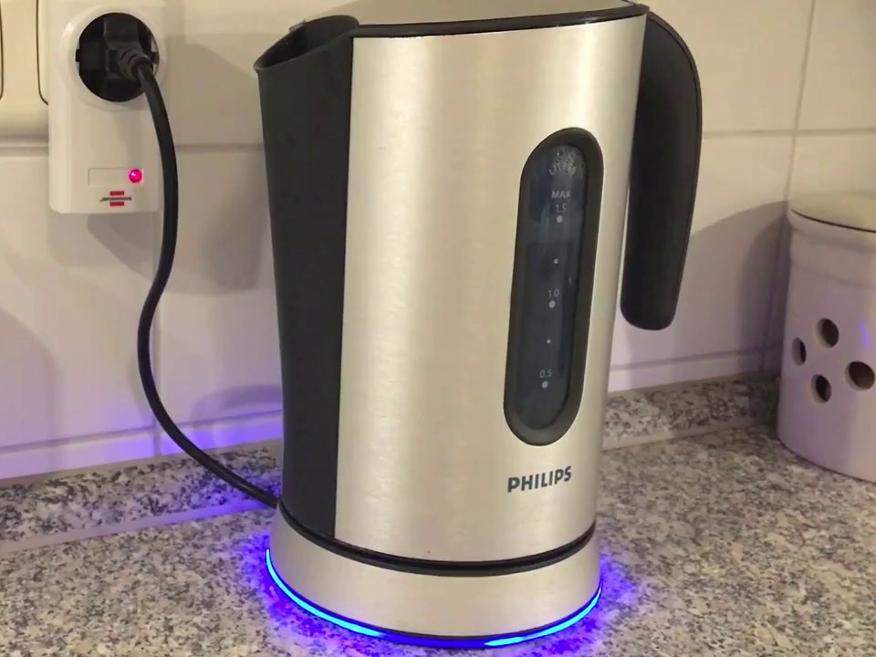 | 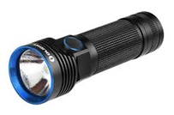
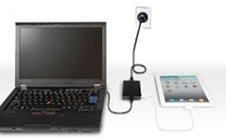 | 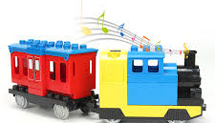
Electricity – Year 4
Significant scientist
Thomas Edison  (1847-1931)  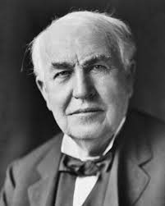 | Thomas Edison was an American inventor. He is sometimes described as America’s greatest inventor. He invented the first practical incandescent light bulb.

Electrical circuit with a bulb
switch
cell

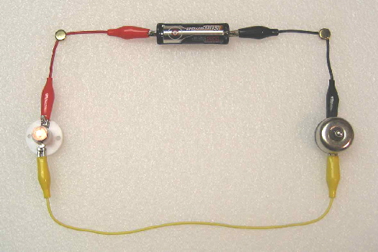
wire
bulb

The switch opens and closes the circuit. The bulb lights in this circuit because the switch is on.

This circuit will not work as it is not complete. | 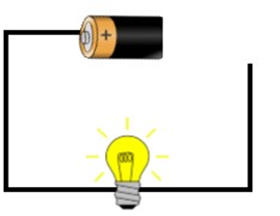
This circuit is complete so the buzzer will sound and the bulb will light. | 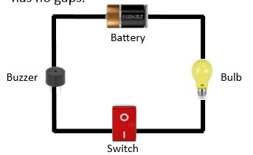

Conductors and insulators
Conductors
Some materials let electricity pass through them easily. These are known as electrical conductors. Many metals are good electrical conductors, such as iron, copper and steel.
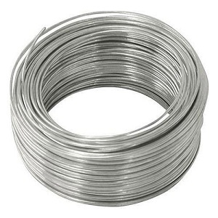 | 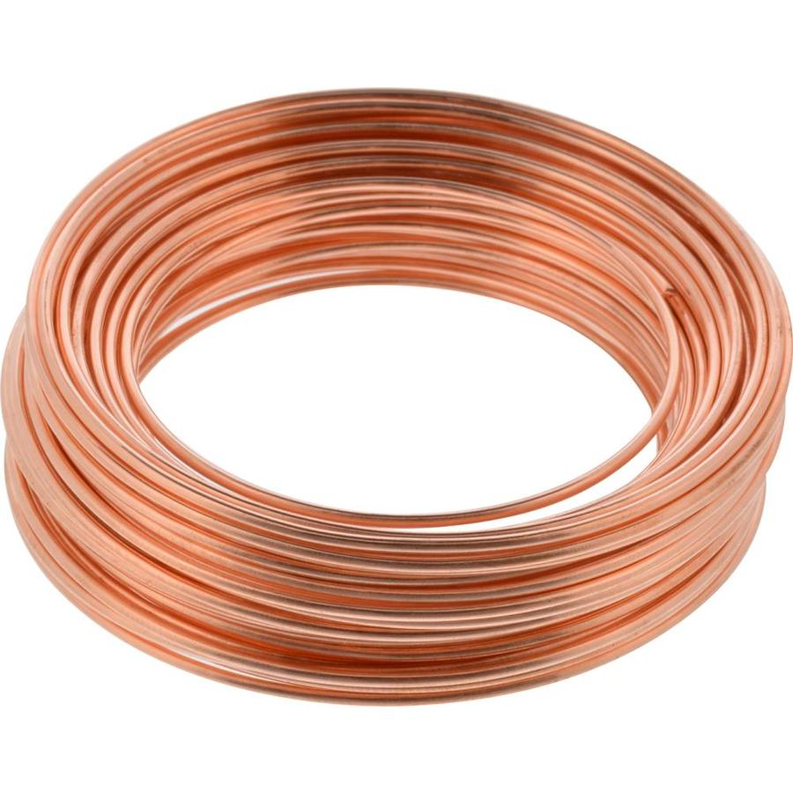
Insulators
Some materials do not allow electricity to pass through them. They are known as insulators. Plastic, wood, rubber and glass are good electrical insulators.
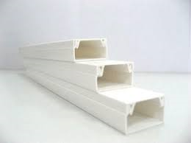
© ECM Education Consultants 2019

