Love Learning, Love Life Always Aiming High
Welcome to Reception Class!

This term our topic is ‘Into the woods’. We have chosen this topic because the children are becoming increasingly interested in our outdoor area. They love to explore and are beginning to ask very interesting questions. This topic will enable us to bring together all these interests and teach the children about insects, animals and habitats around the world.
We will encourage the children to learn as much about the woods and minibeasts as possible, using the internet and non- fiction books to find out interesting facts. We will also explore fiction books such as ‘Silly Doddy!’, ‘cave baby’, ‘The Very Hungry Caterpillar’, ‘The Bad Tempered Ladybird’, ‘Aaaagh Spider’ etc.
Ways to help at home-
Practise letter sounds and names as well as ‘ch, sh, th, ng, nk, ay, ee, igh, ow,
Encourage your child to write simple sentences and ask if they can read them back. Remind them to use ‘Fred fingers’ when ‘segmenting to spell’. As you know, these are terms that they are familiar with.
When reading at home ask as many ‘why’ and ‘how’ questions as possible in order to extend their thinking. ‘Why do you think she did that?’ How is he feeling? But how do you know?
Practise number recognition to 20 (and beyond) and see if they can order these numbers. Ask them to identify what one more and one less than any given number is.
Encourage and support them in using language related to time and money. Ask if they would like to pay for smaller items in the shop. Talk about the coins, seeing if they can recognise any.
Talk as much as possible! Talk about family, friends, where you live, what your child likes and dislikes, what they are good at, their hobbies, your hobbies, anything and everything! Share feelings, thoughts and opinions. If children are confident to talk and when they are ready to write, their ideas will simply flow.
Question why things happen and how things work. Have discussions about all things big and small- from ‘what do you fancy for tea?’ to ‘why do you think fish can’t live on land?’
Talk about the importance of our similarities and differences- that we may like different things, have different skills and look different to each other but that it is those differences that make us special.
Many thanks for your continued support and if you ever have any questions please feel free to ask.

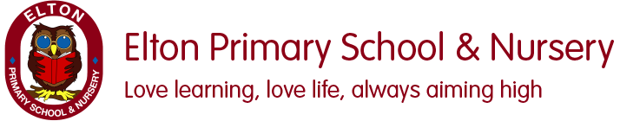

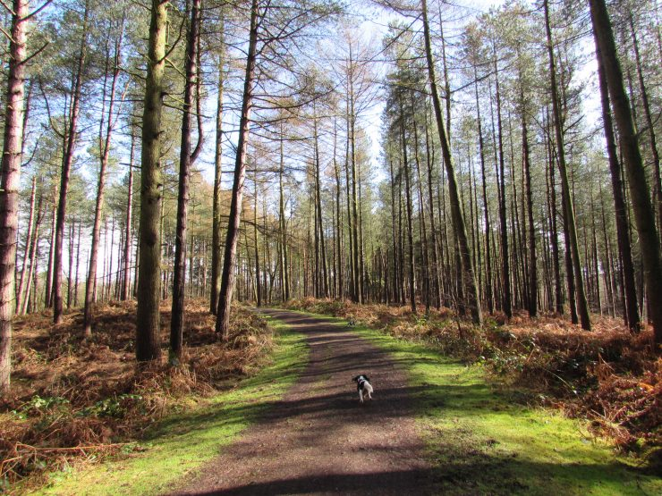 Into the Woods

Term: Summer 1 Topic: Into the woods Year Group: Reception
 | English | Maths | Wider Curriculum
 | Silly Doggy! | 20 and beyond, Then and Now | Into the Woods
Book links | 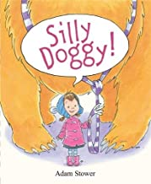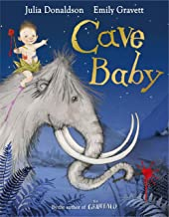 | 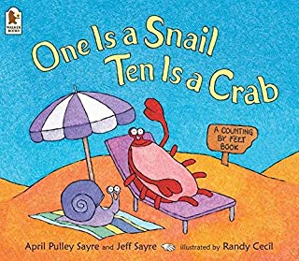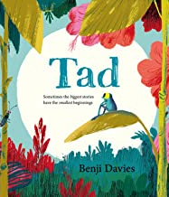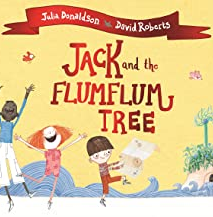 | 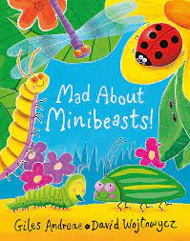  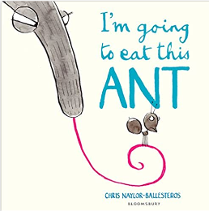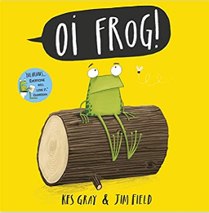
Specific Vocabulary | Rhyme  Segment  Blend  Author  Illustrator  Capital letter  Full stop  Finger space | doubling  sharing  grouping  Equal Groups  Half  Odd  even | Grow,  Change,  Seasons  Minibeasts  Transform  Woodland
Sticky Knowledge about… | A sentence needs:  Finger space between words  Full stop at the end.  I know the sounds:  ay, ee, igh, oo, ow  I can read words which have these sound in them.  I know the tricky words:  I, to, the, go, no, said, me, she, he, you | I know how to count on and back within 10.  Recognise and form numerals 1-10.  Identify and build number to 20.  Halving something is when things are split into two equal groups.  Doubling something is when you have 2 of the same amount.  An even number is a number that can be divided into two equal groups. An odd number is a number that cannot be divided into two equal groups. | Animals and minbeasts live in the woods.  Minibeasts are ‘small animals’, like worms, snails, ladybirds, insects and spiders. Scientists call them ‘invertebrates’ – animals without a backbone.  I know about similarities and differences when learning about living things.  I can talk about the things that make my own environment ‘special’ and how, where people and small animal live might be different from one another.  I know what makes animals and plants special and explain why some things happen, and talk about changes such as the life cycle of a caterpillar.

