Term: Autumn 1 Topic: Starlight Year Group: Reception
 | English | Maths | Wider Curriculum
 |  | 1,2,3, it’s me, Light and Dark
Book links | 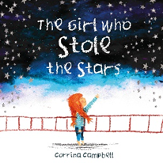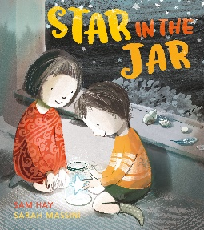 | 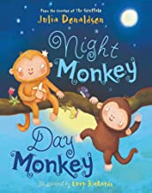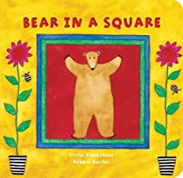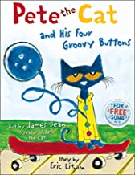 | 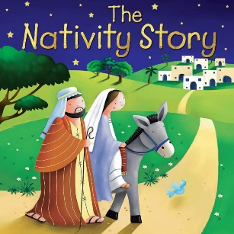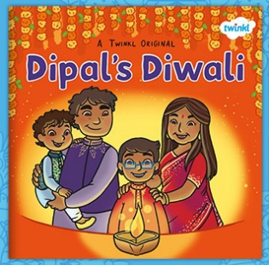
Specific Vocabulary | Author  Illustrator  Setting  Character  Anteater | More  Fewer  Morning  Afternoon  Evening  Night  Circle  Square | Celebration  Diwali  Festival of light  Nativity  Seasons  Summer  Spring  Autumn | Winter  Freezing  Boiling
sticky Knowledge about… | Set one sounds:  m, a, s, d, t, I, n, p, g, o, c, k, u, b, f, h, l, e, r, j, y, w, z, x, y, qu, ch, sh, th, ng ,nk  Letter have a sound and a name.  Know the first sound of a word.  Know how to us a tripod grip.  I know how to write my own name.  Information can be retrieved from books and computers. | Circles have 1 curved side and that triangles have 3 straight sides.  Squares and rectangles have 4 sides.  Subitise up to 5 items.  1 more and 1 less up to 5.  I know the time of the day | There are four season.  The seasons are called, Spring, Summer Autumn and Winter.  Christens celebrate Christmas.  Christmas is to celebrate the birth of Jesus.  Diwali is a Hindu celebration.  Diwali is the festival of light.

