Focus: Art | Pop Art | Year 4 | Autumn 1

Key Knowledge

Pop Art Movement- Pop Art is a style of Art based on simple, bold images of everyday items, such as soup cans, painted in bright colours. Pop artists created pictures of consumer product labels and packaging, photos of celebrities, comic strips, and animals.
Roy Lichtenstein was an American Pop Artist. Roy Lichtenstein was born in New York in 1923. He became famous for his bright and bold paintings of comic strip cartoons as well as his paintings of everyday objects.
Through the use of primary colours, thick outlines, and Benday dots, Lichtenstein endeavoured to make his works appear machine-made.
Lichtenstein often used Onomatopoeia in his Comic Book style paintings.
'Onomatopoeia' is the name for words which create sound effects, eg pop, bang.

Possible Experiences
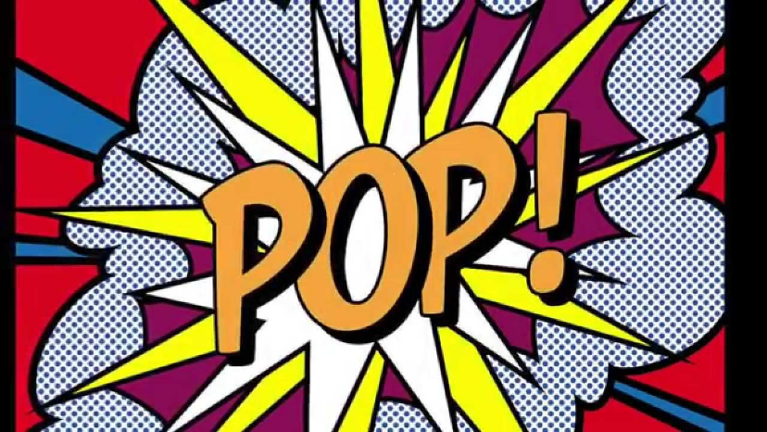
- Design & paint a Pop Art style Zoo poster.

- Research and present information about Roy Lichtenstein.

Key Vocabulary

Onomatopoeia- a word that sounds like its meaning, eg. pop
Pop Art- a style of Art which has simple, bold images. It started in the 1950’s
bright – vivid, brilliant
bold - striking
primary colours – red, yellow, blue
secondary colours- orange, green, purple
benday dots – created by Benjamin Day. A printing process which combines 2, or more, different coloured dots to create a third colour.

Roy Lichtenstein

