Focus: DT | Moving Toys | Year 4 | Summer
Key Vocabulary

Functional
Aesthetic
Linear
Rotary
Assemble
Join
Cam – round, snail, eccentric, egg-shaped, ellipse, hexagon
Handle

Key Knowledge

Use previous experiences in DT to generate ideas.
Research different types of mechanisms.
Recognise the movement of a mechanism in a toy or model.
Understand that a cam will change rotary motion into linear motion.
Explore how different shaped cams produce different movements.
Explain the relationship between a cam and a follower.
Select the most sensible tools, materials, equipment and components to create a product.

Design brief: To design and construct a moving toy with a cam.
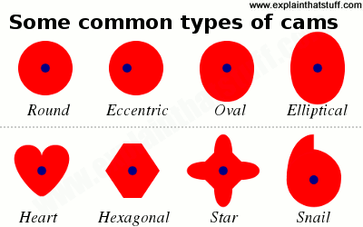
Functional considerations: The toy needs to be able to move in a linear motion. The movement must be noticeable and smooth.

Aesthetic consideration – the toy needs to be themed for a small child.

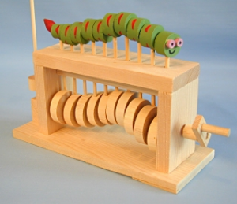
The eccentric cam – this rotates as it is fixed to the axle which is turned by the handle.

The follower cam – the eccentric cam causes the follower to move up and down (linear) and rotate.

Linear motion – straight line

Rotary motion – turning in a circle

