Key vocabulary
Vincent Van Gogh | texture
artist | line
pattern | form
shape | portrait
space | landscape
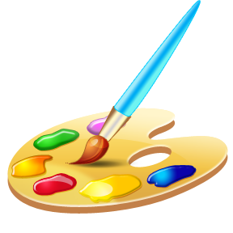
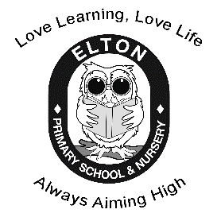
Which different media could we use to recreate this piece of art?
Art – Year 1
Van Gogh’s Starry Night
Vincent Van Gogh
1853-1890
He painted portraits and landscapes.
He used a swirling effect in his paintings.
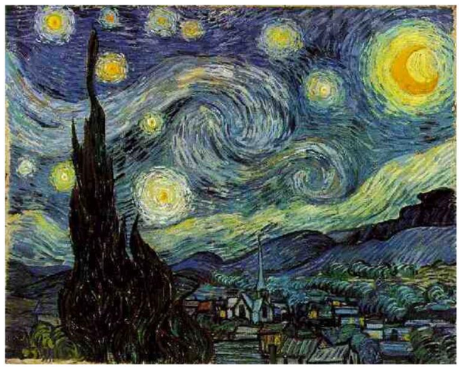
The Starry Night

Vincent Van Gogh

landscape | a painting showing a view of natural scenery, like the countryside
artist | a person who creates paintings, drawings and sculptures
portrait | a painting of a person
texture | the feel of a surface

