Term: Summer 1 Topic: Into the woods Year Group: Reception
 | English | Maths | Wider Curriculum
 | Silly Doggy! | 20 and beyond, Then and Now | Into the Woods
Book links | 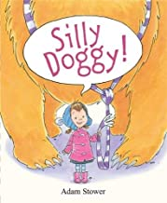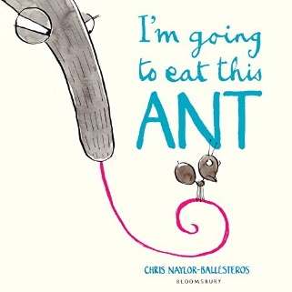 | 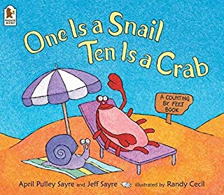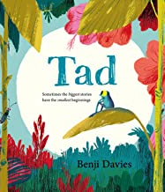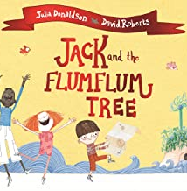 | 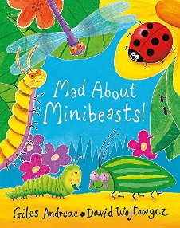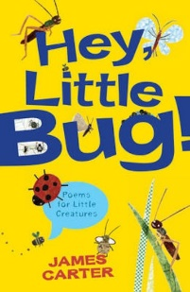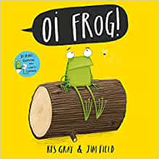
Specific Vocabulary | Rhyme  Segment  Blend  Author  Illustrator  Capital letter  Full stop  Finger space | doubling  sharing  grouping Equal Groups  Half  Odd  even | fierce  shaggy  speedy  spotty  cunning
Sticky Knowledge about… | A sentence needs:  Capital letter to start  Finger space between words  Full stop at the end.  I know the sounds:  ay, ee, igh, oo, ow, oo, ar, or, air, ir  I can read words which have these sound in them.  I know the tricky words:  I, to, the, go, no, said, me, she, he, you | I know how to count on and back within 10.  Recognise and form numerals 1-10.  Identify and build number to 20.  Halving something is when things are split into two equal groups.  Doubling something is when you have 2 of the same amount.  An even number is a number that can be divided into two equal groups. An odd number is a number that cannot be divided into two equal groups. | Animals and minbeasts live in the woods.  Minibeasts are ‘small animals’, like worms, snails, ladybirds, insects and spiders. Scientists call them ‘invertebrates’ – animals without a backbone.  I know about similarities and differences when learning about living things.  I can talk about the things that make my own environment ‘special’ and how, where people and small animal live might be different from one another.  I know what makes animals and plants special and explain why some things happen, and talk about changes such as the life cycle of a caterpillar.

