**Welcome back to the Summer term….**

We have been having a great year so far and I look forward to our last term together. Mr Stedmen will be joining is for 4 weeks this terms so we can look forward to some extra help and support.

**So what’s in store...**

Inside this leaflet you will gleam on outline of some of the exciting learning that will take place during our new topic One World. This topic will be led by our English text, ‘The Paperbag Prince’, about an elderly man who lives in a landfill site. We will also be finding out about pollution, recycling and renewable energy through our Geography, Guided Reading and P4C lessons.

PE will continue to be on Monday and Wednesday afternoons this term (outdoors weather permitting/where ever possible)—so please make sure that you have the correct school PE kit in school. Trainers are only necessary for PE lessons/break times if needed, all other times, school shoes should be worn please.

Correct uniform should be worn at all times please. This is a school jumper/cardigan, or one in a similar colour, a white polo neck top, grey skirt, shorts or trousers and black shoes. For PE, this is a white top, white or black shorts and trainers or pumps. Jogging bottoms or leggings can be brought in for colder weather, but please try to make sure they are black or white.

Learning Log homework and Maths will continue to be given out on a Friday and should be returned on a Wednesday.

As always, reading is the cornerstone of all learning. We recommend reading a wide range of texts both at home and at school, this includes your child’s school reading book and their own personal reading books. Please continue to listen to your child read and sign their reading records at least 3 times a week. By Year 5, we expect the children to also record any home reading they do themselves in their reading record, however it would be great if you could sign it to confirm they have read. The children receive rewards after every 10 reads. We are also taking part in the whole school ‘Million Words’ competition where we (as a school) are aiming to read one million words between us.

Please ensure all uniform is named, and that water bottles are taken home and cleaned daily.

We look forward to seeing you all soon, any questions please ask.

 Miss Allen

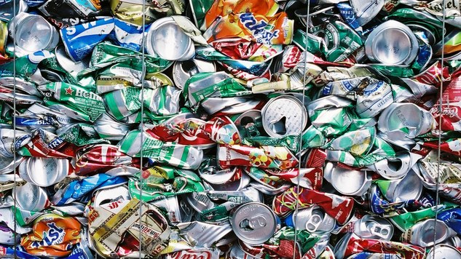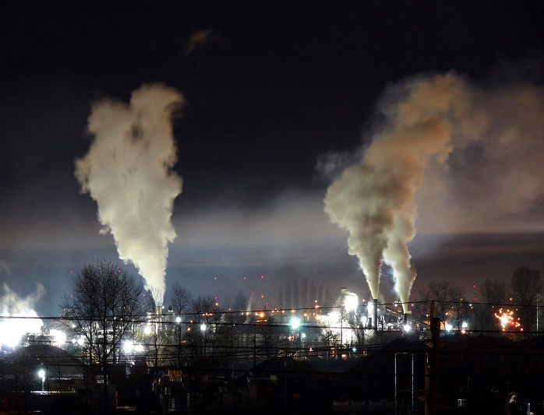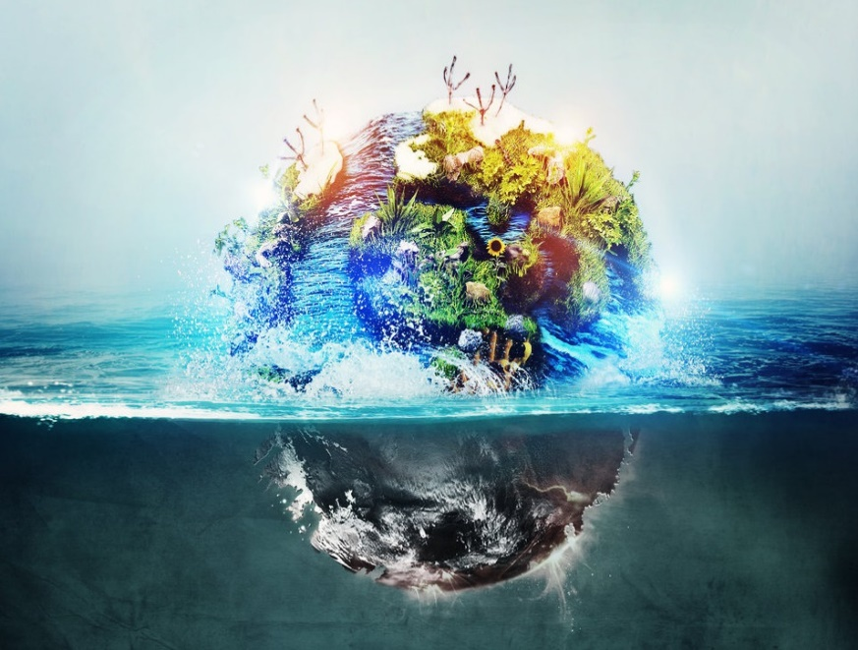

**One World**

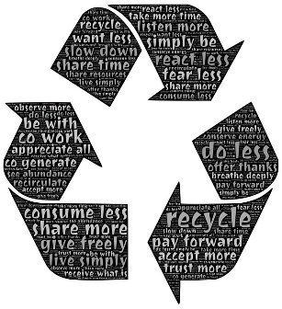

**Topic Overview:**

This term our learning will be lead by our text ’The Paperbag Prince’, an interesting and though-provoking book, which will cause us to consider the impact we’re having on our planet, and how we can help to future-proof our world.

After half term, we will begin to learn about different cultures, from Africa to Baghdad to the Mayans, there’s a lot of different and fascinating worlds to discover and explore.

**English:**

During the first half term, we will be focussing on persuasive writing, creating a leaflet which expresses our opinion and uses a variety of skills. Our mastery skills for this will be: using modal verbs to indicate degrees of possibility, building cohesion within our writing, using parenthesis punctuated with brackets, commas and dashes, and using a wide range of vocabulary.

 After half term we move onto fictional writing, writing a story based around our book ‘The Hunter’.

Our mastery skills for this will be: using relative clauses, using adverbs and adverbials, improving our cohesive

writing through use of conjunctions, verb tenses, adverbials, and linking ideas together using tense choices.

We will continue to develop our comprehension and inferential skills in guided reading and as a whole class share a range fiction and non-fiction texts. Throughout, spelling, punctuation and handwriting remain a priority in all our work.

**Maths:**

We will begin the term by looking adding and subtracting decimals, as well as multiplying and dividing them. After this, we will move on to Geometry. Here we will be discussing 2D and 3D shapes, comparing and naming angles, drawing and measuring angles, and finding missing angles.

After half term, we will move on to measure—finding mass and capacity, and converting between different units of measurement. We will also recap perimeter and area from Spring, before moving on to telling the time, converting analogue and digital clocks and calculating time durations.

**Science:**

Within Science this term, we will be learning about properties and changes of materials. We will compare and group everyday materials on the basis of their properties, learning about solubility, flexibility, transparency, and conductivity. We will also investigate which materials dissolve in liquids to form solutions, and will find out about how we can separate solutions using filtering, sieving and evaporating. After this, we will go on to learn about how some change are reversible and some irreversible. It should be a fascinating, Chemistry based unit.

**ICT:**

We will begin this term by undertaking a unit about building our own apps. We will be focussing on the planning, designing and creative processes behind creating our own apps, which will be based on something we have learnt about this school year. We will then go on to find out about how computers work, and what impact they have on our lives.

**Geography and History:**

We will begin this half term with Geography. Our unit of work will focus on local Geography, and we will be using a variety of maps to find out about how the land use around Elton, Chester and Ellesmere Port has changed. We will also be discussing why our area has changed, and looking at what the future is for our region. After half term, we will turn to History, and will be learning all about ancient civilisations, and comparing the history of Britain to that of a contrasting, Non-European country.

**Design Technology and Art:**

Our focus in DT is on creating new from old, linking to our work on recycling.

We will be using junk collected over time to create our own train carriages,

inspired by our text;The Paperbag Prince’. Later in the term we will use our art skills to create images of elephants on cloth, using the Batik style of decorating on fabric.

**PE:**

PE lessons will continue be taught on a Monday afternoon and a Wednesday afternoon. We will continue improving our rounders skills and after halt term, we will focus on athletics skills.

**MFL:**

This term, we will begin by recapping the names of parts of the body. We will then move on to discussing how we’re feeling, and then to naming jungle animals. Then, we will learn to describe jungle animals, before moving on to discussing the weather.

**P4C:**

In P4C, you will be learning all about recycling, linking into our learning in English and reading. We will then go on to look at mental health, including bullying, respect, tolerance and compassion. We will also be discussing personal space, consent and respect for privacy.

**Music:**

This term, we will be learning all about the popular hit from the 1960s, Dancing in the Street. We will then go onto reflect on our learning so far this year, and practise and perform a piece based on our learning.

**RE:**

In the first half term we will be finding out more about Christianity, including Christian values, celebrations and what these tell us about how Christians live their lives. We will then go on to apply this learning in Christianity to the world view Humanism. We will be discussing Humanist values and celebrations, and how these compare to and differ from those of Christians.

