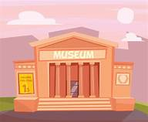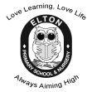

**Year 1 Learning Leaflet**

**Spring 2021**

What would you put in your own museum?

**Love Learning, Love Life**

**Always Aiming High**

Welcome back!

Welcome back after the Christmas break; we hope that you have had a lovely time with all of your family. We are so excited to start our learning this term.

PE will be on a Wednesday and Thursday afternoon so you will need to make sure to have your PE kit in school on these days. Your PE kit can stay in school to make sure we have it ready for these days.

Remember to bring a water bottle into school with you.

You will be given homework which will be sent home on Fridays. Each week we will send home a piece of literacy and numeracy homework. You need to bring your homework back in on the following Wednesday.

We will change your reading books once a week and will read together during ‘Group Reading’ as well as having an individual read with an adult.

Always remember to bring your reading books into school with you, along with your reading log.

Try to practise at home with your grown-ups, this way you will become superstar readers! It would be lovely to hear about books you have enjoyed reading ☺

We can’t wait to see all of your wonderful work this term!

Miss Curry and Miss Price ☺

In Geography we will be focusing on the location of hot areas of the world in relation to the Equator. We will study Africa and recognise similarities and differences to where we live.

In History we will learn about Changes within living memory. We will focus on what household items and toys our grandparents/great grandparents had. We will look at how toys have changed over the years.

What would you put in your own museum?

is a cross curricular topic. The children will learn about changes within living memory – what household items and toys our grandparents/great grandparents had. We will also focus on hot areas of the world and the equator.



In Computing we will be completing a unit called ‘Me and my selfie’. We will be using the camera to take different kinds of photographs of things around us. We will use the apps Prisma and Lunapic to edit our photographs. We will learn to add effects and text.

In P.E we will focus on Gymnastics and Dance. We will explore and develop skills, actions and movements in the following areas: shapes, travelling, jumping, balancing, rocking and rolling. We will use expression and choreography. In Music we will be looking at different styles of music - Blues, Latin, Folk, Funk, Baroque, Bhangra. We will be singing and learning simple songs.

****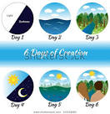

In English we will continue to follow Pathways to Write. We will be focussing on the stories The Lion Inside by Rachel Bright and The Curious Case of the Missing Mammoth by Ellie Hattie. We will continue to punctuate sentences using capital letters and a full stop, some question marks and exclamation marks. Another focus will be on using ‘and’ between words and some clauses. We will move onto the prefix un- and the accurate use of suffixes (where no change is needed to the root word) e.g. -ed, -ing, -er, -est.

We will write simple sentences in sequence and include a beginning, middle and end in our writing.

In R.E we will be looking at Christianity. We will be focussing on the world around us and what makes it beautiful. We will study the Creation story and why it is important to some people. We will be thinking of ways in which we could care for our world and immediate environment.

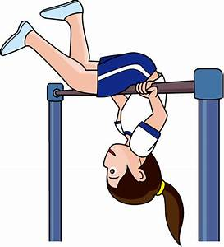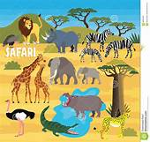

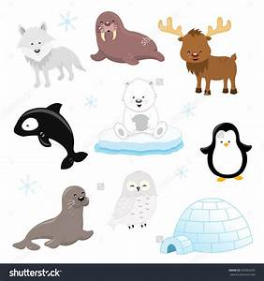

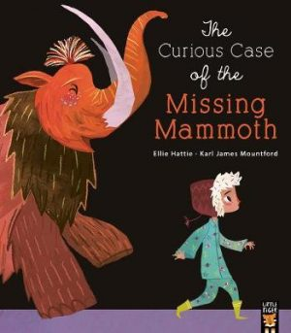

In Maths we will be looking at Number: Addition and Subtraction within 20 and Place value (within 50). We will identify and represent numbers from 11 to 50. We will move onto tens and ones and will add by counting on.

The children will revisit numbers bonds and continue to find one more and one less than a given number, as well as ordering numbers to 50.

They will count in 2s, 5s and 10s and subtract crossing 10.

In Science we will be looking at a topic called ‘Polar Places’. We will be learning about properties of different materials, and a range of living things in the Polar Regions. We will identify and name a variety of animals including fish, amphibians, reptiles, birds and mammals and identify and name animals that are carnivores, herbivores and omnivores. We will describe the simple properties of a variety of everyday materials and compare and group them on the basis of their simple properties.

In **Art** we will create self-portraits to display in our own gallery/museum – we will experiment with line, shape and colour.

In DT we will design and make an animal mask – we will select tools and use lots of different skills: cutting, shaping, joining, finishing and selecting materials.

